
CS 111L – Programming Fundamentals
lab # 04
Decision Making
––
Student Name: Athar Imran
Student ID: 2604277

Assignment Date: 29th September, 2026
Assignment done: 30th September, 2026
Due Date: 06 October, 2026

Lab Task 01: Student Grade & Scholarship Eligibility System
Code:
In this part I have written code for input taking from user and validating it.
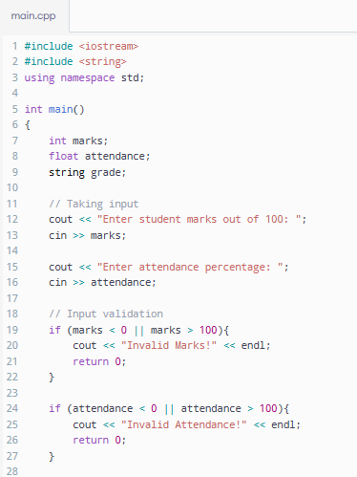

Here, grades for the marks are calculated:
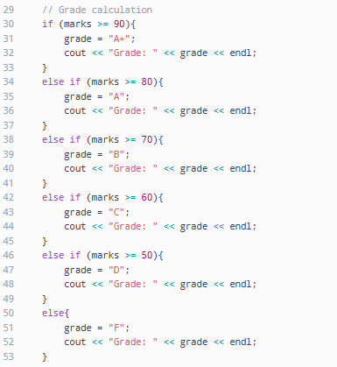
And finally. Scholarship is evaluated:
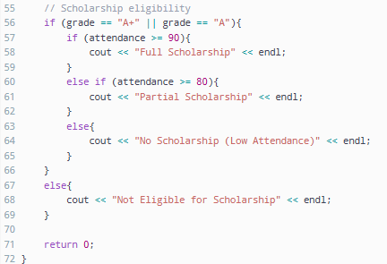

Output 1:
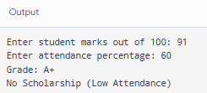
Output 2:
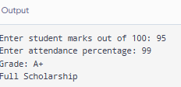
Output 3:
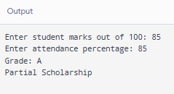
Output 4:
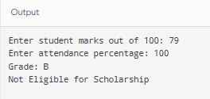
Output 5:
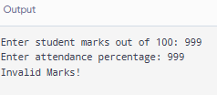

Lab task 02: simple discount calculator
Code:
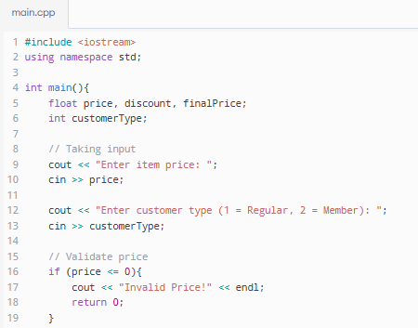
Input is taken and validated.
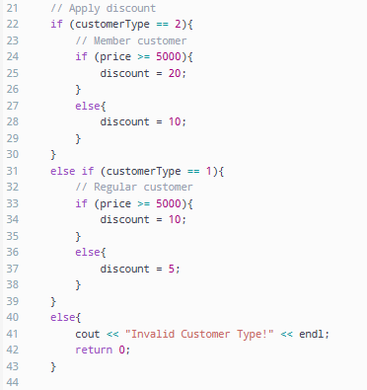
Code for discount.

Final price calculated:
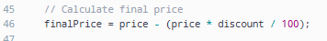
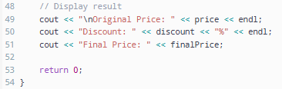
Result.

Output:
